**Customer Centricity**

A **customer** is an individual or organization that purchases goods or services from a business. Customers are essential to businesses as they drive revenue and growth. They can be categorized into different types, such as:

* **New Customers**: First-time buyers.
* **Loyal Customers**: Repeat buyers who consistently purchase from the same business.
* **Impulse Customers**: Buyers who make spontaneous purchases.
* **Discount Customers**: Buyers who are motivated by sales and discounts.

Understanding customer needs and preferences is crucial for businesses to provide excellent service and build long-term relationships.

The psychology of customers, also known as **consumer psychology**, explores how people's thoughts, beliefs, feelings, and perceptions influence their buying behaviours. Here are some key aspects:

1. **Decision-Making Process**: Understanding how customers make purchasing decisions, including the steps they take from recognizing a need to evaluating and choosing a product
2. **Motivation**: Identifying what drives customers to make purchases, such as emotional needs, social influences, or practical requirements
3. **Perception**: How customers perceive products and brands, which can be influenced by marketing, packaging, and personal experiences
4. **Social Influence**: The impact of friends, family, and social media on customers' buying choices
5. **Behavioural Patterns**: Studying patterns in consumer behaviour, such as impulse buying, brand loyalty, and the influence of trends
6. **Emotional Responses**: How emotions like happiness, fear, or excitement can affect purchasing decisions

Consumer psychology helps businesses tailor their marketing strategies to better meet the needs and preferences of their target audience, ultimately enhancing customer satisfaction and loyalty.

**What is customer centricity and why is it important?**

<https://www.qualtrics.com/experience-management/customer/customer-centric/>

Showing empathy to customers in the IT industry is crucial for building trust and ensuring customer satisfaction. Here are some effective ways to demonstrate empathy:

1. **Active Listening**: Pay close attention to what the customer is saying without interrupting. This shows that you value their concerns and are genuinely interested in helping.
2. **Acknowledge Feelings**: Recognize and validate the customer's emotions. For example, saying, "I understand how frustrating this issue must be for you," can make them feel heard and understood.
3. **Personalize Interactions**: Use the customer's name and reference previous interactions or specific details about their situation. This personal touch can make a big difference.
4. **Clear Communication**: Explain technical issues and solutions in simple, jargon-free language. Ensure the customer fully understands the situation and the steps being taken to resolve it.
5. **Timely Responses**: Respond to customer inquiries and issues promptly. Keeping them informed about the status of their request shows that you respect their time and are committed to resolving their problem.
6. **Follow-Up**: After resolving an issue, follow up with the customer to ensure everything is working well and to see if they have any further questions or concerns.
7. **Offer Solutions**: Instead of just pointing out problems, provide actionable solutions. This proactive approach demonstrates your commitment to helping the customer.
8. **Be Patient and Calm**: Even if the customer is upset, remain calm and patient. Your composed demeanor can help de-escalate the situation and reassure the customer.

By incorporating these practices, IT professionals can build stronger relationships with their customers, leading to increased satisfaction and loyalty. Is there a specific scenario or challenge you're facing where you need to show empathy?

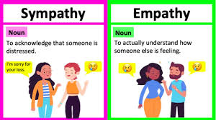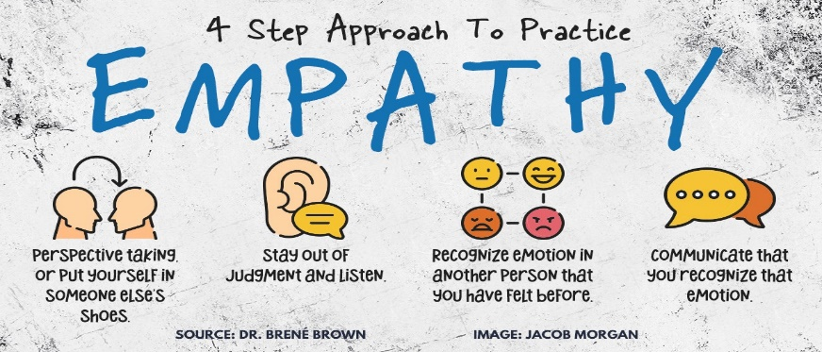

Improving client relationships is essential for long-term success and client retention. Here are some strategies to enhance these relationships:

1. **Understand Their Needs**: Take the time to understand your clients' goals, challenges, and expectations. This helps in providing tailored solutions that meet their specific needs.
2. **Regular Communication**: Maintain consistent and open communication. Regular updates, check-ins, and feedback sessions can help keep the relationship strong and address any issues promptly.
3. **Deliver Value**: Always aim to provide value beyond the basic services. This could be through sharing industry insights, offering additional resources, or suggesting improvements that benefit the client.
4. **Be Reliable and Trustworthy**: Ensure that you meet deadlines, keep promises, and maintain a high standard of work. Reliability builds trust and confidence in your services.
5. **Personalize Interactions**: Treat each client as unique. Personalize your interactions by remembering details about their preferences, past interactions, and specific requirements.
6. **Show Appreciation**: Acknowledge and appreciate your clients. Simple gestures like thank-you notes, special discounts, or personalized gifts can go a long way in showing that you value their business.
7. **Seek Feedback**: Regularly ask for feedback and act on it. This shows that you are committed to improving and value their input.
8. **Be Proactive**: Anticipate your clients' needs and address potential issues before they become problems. Proactive support demonstrates your dedication to their success.
9. **Build a Strong Team**: Ensure that your team is well-trained, knowledgeable, and aligned with the goal of providing excellent client service.
10. **Stay Updated**: Keep up with industry trends and advancements to offer the most current and effective solutions to your clients.

By implementing these strategies, you can build stronger, more positive relationships with your clients, leading to increased satisfaction and loyalty. Is there a specific area where you're looking to improve your client relationships?

Singapore is renowned for its exceptional customer service due to several key factors:

1. **Cultural Emphasis on Service**: Singapore places a high value on hospitality and service excellence. This cultural emphasis is reflected in the training and expectations set for service providers
2. **Comprehensive Training Programs**: There are numerous customer service training programs, such as the WSQ Service Excellence courses, which focus on developing practical skills and the right mindset for delivering outstanding service
3. **Strong Service Standards**: Companies in Singapore often adhere to stringent service standards and continuously strive to exceed customer expectations. This is evident in industries like hospitality, retail, and aviation
4. **Government Support**: The Singaporean government supports initiatives to improve service quality through various programs and subsidies, such as Skills Future, which helps individuals and businesses invest in service excellence training
5. **Innovation and Technology**: Singapore leverages advanced technology to enhance customer service. This includes using data analytics to understand customer needs better and implementing efficient service delivery systems
6. **Customer-Centric Approach**: Businesses in Singapore prioritize a customer-centric approach, focusing on understanding and anticipating customer needs to provide personalized and memorable experiences

These factors collectively contribute to Singapore's reputation for outstanding customer service. Is there a specific industry or aspect of customer service in Singapore you're particularly interested in?

Ron Kaufman is a renowned expert in customer service and service culture. Here are some key lessons from his teachings:

1. **Definition of Service**: Kaufman defines service as "taking action to create value for someone else." This broad definition applies to all types of service, whether internal or external, senior or frontline
2. **Uplifting Service**: His concept of "Uplifting Service" emphasizes creating value at every interaction. This involves understanding what others value and finding ways to deliver that value consistently
3. **Seven Rules of Service Leadership**:
   * **Set the Example**: Leaders should model the behavior they expect from their teams.
   * **Build a Service Culture**: Create an environment where service excellence is a core value.
   * **Communicate Clearly**: Ensure everyone understands the service vision and goals.
   * **Empower Employees**: Give team members the tools and authority to deliver great service.
   * **Recognize and Reward**: Acknowledge and reward excellent service behaviors.
   * **Continuously Improve**: Always look for ways to enhance service delivery.
   * **Measure and Monitor**: Track service performance and make data-driven improvements  
     3.
4. **Customer Service Training**: Kaufman offers comprehensive training programs that focus on building a culture of service excellence. These programs teach principles, frameworks, and tools to help teams deliver superior service
5. **Service Recovery**: He emphasizes the importance of turning service breakdowns into opportunities to build loyalty. Effective service recovery can transform a negative experience into a positive one